# **Together We Are…**

**The Social Work Unit:**

* The **Consultant Social Worker (CSW)** will lead and manage the Unit and support staff to practice consistently high quality social work. They will be responsible for all cases the Unit holds, as well as managing the day-to-day work of the Unit. They will work directly with young people, deliver systemic interventions and lead the Unit whilst embedding a transparent, collaborative and reflective culture.
* The **Social Worker** undertakes social work activity with families and is supervised by the Consultant Social Worker.
* The **Children’s Practitioner** also works directly with families and is supervised by the Consultant Social Worker.
* The **Clinical Practitioner** undertakes clinical assessments of families and works with the members of the Unit to consider how to bring systemic approaches into all the work they do.
* The **Unit Coordinator** co-ordinates the activities of the Social Work Unit by managing diaries and meetings. They are often the first point of contact with families, and are invaluable in freeing up practitioner time.

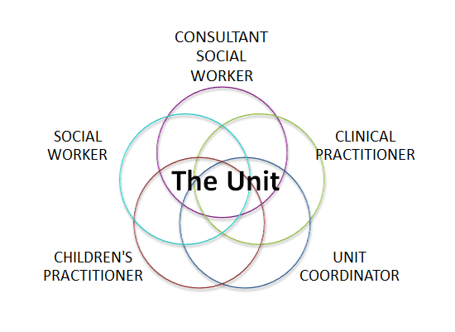

**Reclaiming Social Work in Aberdeen**

**1: Overview**

Together we are changing Children’s Social Work in Aberdeen: the way we work with each other, our partners and most importantly our families in need. We are cutting bureaucracy and redesigning our services to enable staff to work systemically and collaboratively in small Social Work Units.

***What is Reclaiming Social Work?***

The Reclaiming Social Work model is a whole system redesign of social work services for families in need in Aberdeen City.

Social workers play a really important part in helping and supporting families in need and we want to make sure that they are free to focus on this work. This is why we have made a number of changes to enable social workers to work more collaboratively and concentrate on social work, not unnecessary bureaucracy. To achieve this we are redesigning our service into systemic Social Work Units as well as providing training in systemic practice for all our staff.

*UK Government advisor Professor Eileen Munro has been quoted as saying that*

*“Reclaiming Social Work has improved the interaction between families and staff, as well as re-establishing the family as the primary focus of social work. Reclaiming Social Work is about putting children and families at the centre of everything that we do.”*

***Why Reclaiming Social Work?***

The model has proven highly effective for local authorities working in this way. A report underwritten by the London School of Economics stated that Reclaiming Social Work showed ‘an improved approach in interaction with families’ and that there were fewer constraints on practice.

Additionally, a report published in June 2013 by the Tilda Goldberg Centre at the University of Bedfordshire entitled, “An Evaluation of Systemic Units as an Approach to Delivering Children’s Services,” finds in favour of the Reclaiming Social Work approach.

The report found that Reclaiming Social Work created systemic units that delivered:

* 2 to 3 times more time spent with children & families and positive outcomes for them
* reduced numbers of children in care
* better decision making around risk
* high quality assessments
* consistently high levels of skill in direct work with families
* an ability to provide more intensive help for families – particularly at times of crisis or for families with complex problem

*"We are confident that this will deliver a better and more family friendly service for the city.”*

*Councillor Lesley Dunbar, Aberdeen City Council's social care* spokeswoman.

The research also showed that implementation of Reclaiming Social Work has:

* impacted upon staff retention
* reduced staff sickness levels
* significantly reduced bureaucracy

*“Aberdeen is the first Local Authority in Scotland to implement Reclaiming Social Work fully. We are extremely proud of this and how we work with our partners during the implementation of Reclaiming Social Work is really important to us.* *This is a time of change for many of our staff and we are grateful for their dedication to Children’s Social Work at this time. We have developed a timeline for the implementation of Reclaiming Social Work and we expect that the first Units will go live in February 2016.”*

*Bernadette Oxley, Head of Children’s Social Work in Aberdeen*

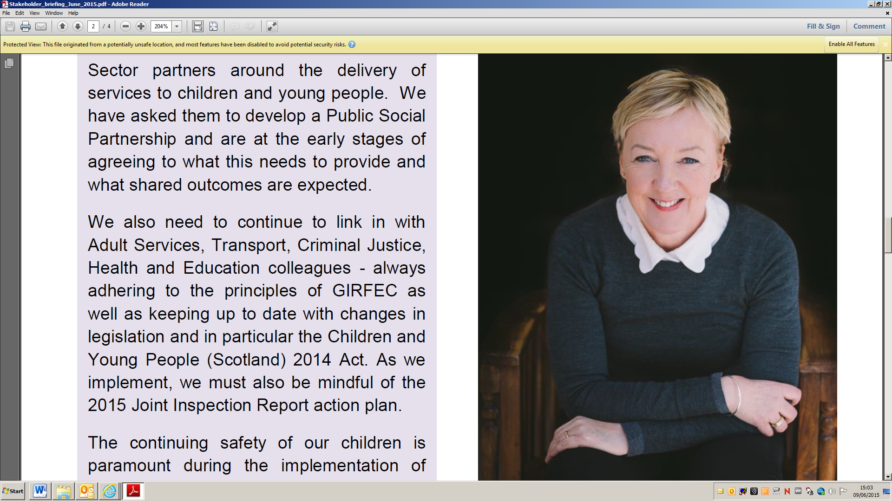 *Government advisor Professor Eileen Munro has been quoted as saying that*

*“Reclaiming Social Work has improved the interaction between families and staff, as well as re-establishing the family as the primary focus of social work. Reclaiming Social Work is about putting children and families at the centre of everything that we do.”*

**Reclaiming Social Work in Aberdeen**

|  |  |  |
| --- | --- | --- |
|  | *For more information about Reclaiming Social Work in Aberdeen or about jobs in Children’s Social Work in the city please contact us by e-mail:* [*together@aberdeencity.gov.uk*](mailto:together@aberdeencity.gov.uk) *or by phone on 01224 522533 or at our website http://www.aberdeencity.gov.uk/jobs_careers/jobs_and_careers.asp* |  |